Experiment 4
Setting Up a Local Area Network (LAN)
AIM: To Set Up a Local Area Network (LAN) using Cisco Packet Tracer
Equipment Required:
- PC-4-Ethernet enabled
- Network Switch-1-8/16/24 port
- Ethernet Cables-4-Straight through, RJ – 45
Network Diagram:
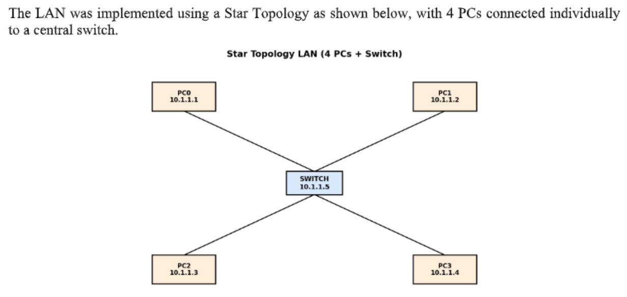
IP Address Configuration Table:
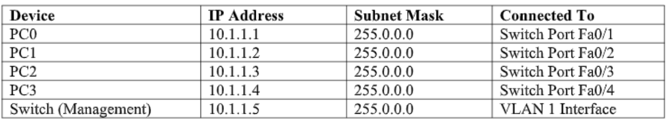
Step 1: Place Devices
1. Open Packet Tracer and place 4 PCs and 1 switch (2960).
Step 2: Connect Devices
2. Use Copper Straight-Through cables to connect PCs to switch ports Fa0/1–Fa0/4.
Step 3: Assign IP Addresses
3. Go to PC → Desktop → IP Configuration and assign static IP addresses and subnet masks.
Step 4: Configure Switch IP (Optional)
4. Enter these commands in the switch CLI:
enable
configure terminal
interface vlan 1
ip address 10.1.1.5 255.0.0.0
no shutdown
exit
Step 5: Test Connectivity
5. Open PC → Desktop → Command Prompt and use ping to test connectivity between PCs.
Step 6: Demonstrate Data Sharing
6. Add a server, connect it to the switch, assign IP 10.1.1.10, enable HTTP, and access its IP through a PC's web browser.
Step 7: Observe Packet Flow
7. Switch to Simulation Mode and observe packet movement using the Play/Capture controls.


